QORVO_RADIO2 Project – PCB Operation Manual– Senior Design II

Date | Revision | Author | Comments
2026-02-17 | REV0 | Luke M. | Original Document Creation
2026-04-02 | REV1 | Luke M. | Added content headers, battery connection, switch state, and J-Link connector content
2026-04-03 | REV2 | Luke M. | Added doorbell, Speaker, Spare GPIO, Test header, Appendix, and motion sensor connector content. Added Appendix Header

Table of Contents
1 Overview of this Document 1
2 Battery Connection 1
3 Switch States 3
4 J-Link Connector 5
5 SMA Antenna 6
6 Test Headers 6
7 Doorbell Connector 7
8 Motion Sensor Connector 8
9 Speaker Connector 9
10 Spare GPIO 10
11 Appendix 11

Overview of this Document
This document is the operational manual for the custom manufactured Printed Circuit Board (PCB). The manual will cover a step by step process on switch states, J-Link connector orientation, and external connector connections.

Battery Connection
The UBBP01 lithium ion battery cells are connected to the B2B-PH-K-S 2 pin connector header. The mechanical design of the header prevents backwards connection as shown in Figure 2-1 and Figure 2-2.

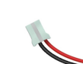
Figure 2-1: Lithium Ion Battery Cell connector

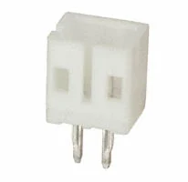
Figure 2-2: 2-Pin Header connector

The 2-Pin Headers are located at the top of the PCB as shown in Figure 2-3 below.

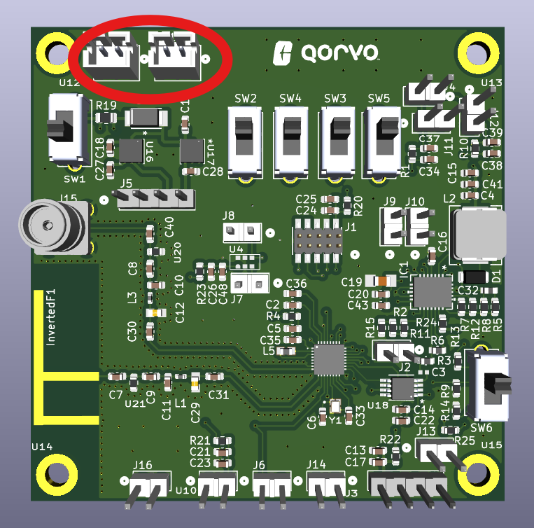
Figure 2-3: 2-Pin Battery Connectors

Switch States
Each PCB features a power switch (SW1) as shown below in Figure 3-1.

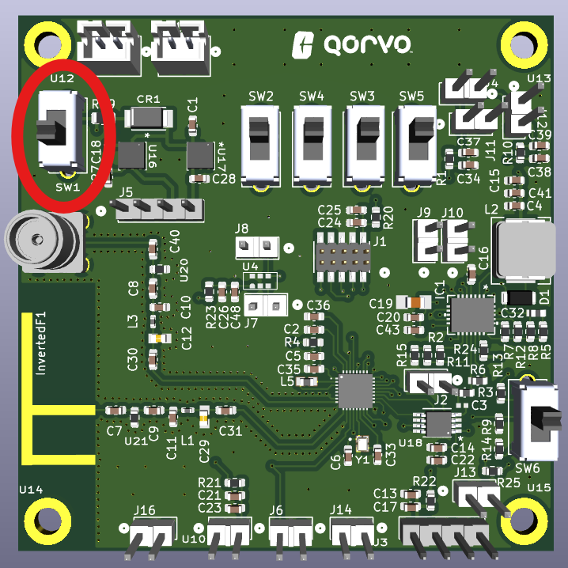
Figure 3-1: Power Switch (SW1)

As shown in Figure 3-1, SW1 is currently in the OFF state (THE BOARD IS NOT POWERED). Flipping the switch up will switch SW1 to the ON state (THE BOARD IS POWERED).

The LM48511 audio amplifier has 4 switches that control internal devices of the IC as shown below in Figure 3-2.

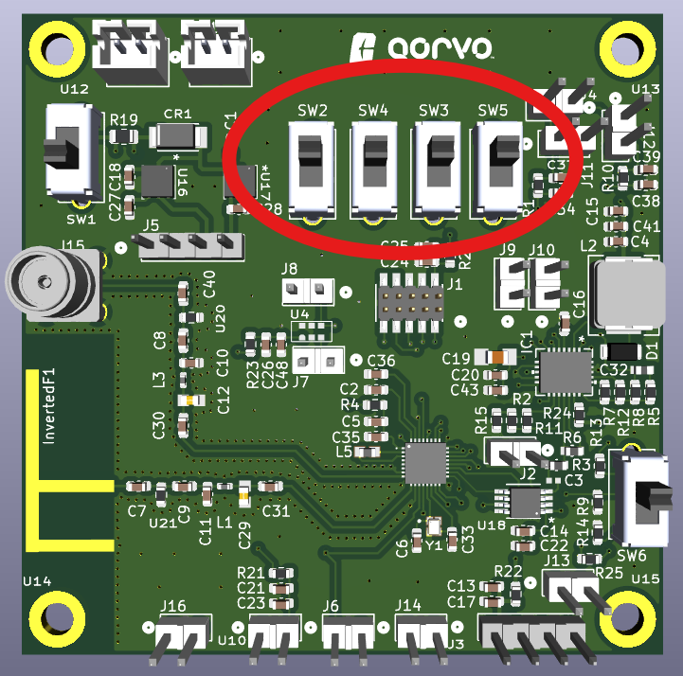
Figure 3-2: Audio Amplifier Switches

SW2 controls the Fixed Frequency mode operation of the IC. As shown in Figure 3-2, SW2 is currently in state 1 (SS/FF is connected to GND), this mode sets the amplifier output to a constant 300 kHz. Flipping the switch down will switch SW2 to state 2 (SS/FF connected to 5V), this state sets the amplifier to its Spread Spectrum Mode operation. In Spread Spectrum Mode, the switching frequency varies randomly by 10% at a center frequency of 330 kHz.

SW3 controls the Regulator Feedback Select operation of the IC. As shown in FIgure 3-2, SW3 is currently in state 1 (FB_SEL is connected to GND), this state sets the amplifier output to a higher voltage output. Flipping the switch down will switch SW3 to state 2 (FB_SEL is connected to 5V), this state sets the amplifier output to a lower voltage output.

SW4 controls the Class D amplifiers within the IC. As shown in Figure 3-2, SW4 is currently in the OFF state (Class D amplifiers are OFF). Flipping the switch down will switch SW4 to the ON state (Class D amplifiers are ON). Switching SW4 to the OFF state reduces supply current to the IC, ideal state when the audio amp isn't in use.

SW5 controls the Boost regulator within the IC. As shown in Figure 3-2, SW5 is currently in the OFF state (Boost regulator is OFF). Flipping the switch down will switch SW5 to the ON state (Boost regulator is ON). Switching SW5 to the OFF state reduces supply current to the IC, ideal state when the audio amp isn't in use.

The QPG6200L requires the PROG_ENn pin to be pulled to a LOW (GND) state for the IC to enter program mode. Program mode allows the J-Link EDU Mini to connect to the QPG6200L. SW6 is used to pull the PROG_ENn pin between two states, HIGH (3.3V), and LOW (GND) as shown in FIgure 3-3.

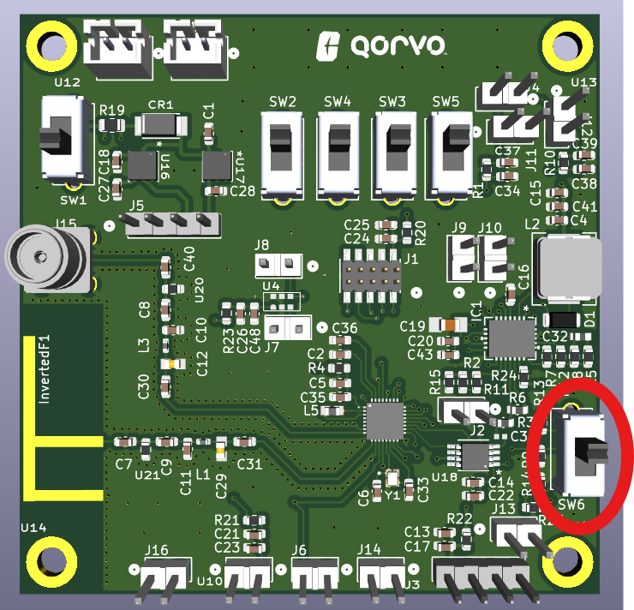
Figure 3-3: PROG_ENn Switch

SW6 as shown in FIgure 3-3 is currently in the HIGH state (PROG_ENn is connected to 3.3V), in this state the QPG6200L will not enter program mode. Flipping the switch down will switch SW6 to the LOW state (PROG_ENn is connected to GND), in this state the QPG6200L will enter program mode, allowing for J-Link connection.

J-Link Connector
To program the PCB the 10 pin connector (J1) will be connected to a J-Link device utilizing a 10 pin ribbon cable. The 10 pin connector is located on the PCB as shown below in Figure 4-1.

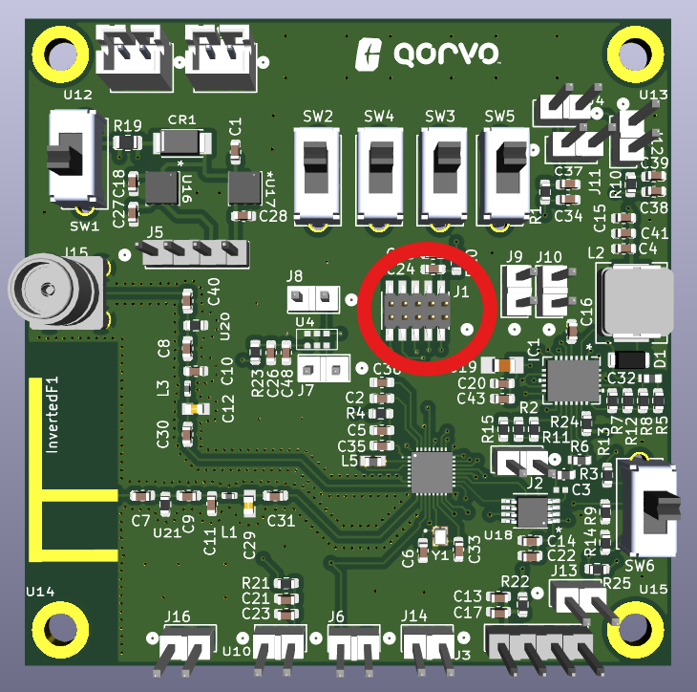
Figure 4-1: J-Link PCB Connection

The pinout for the 10pin ribbon cable follows the connections as shown below in Figure 4-2.

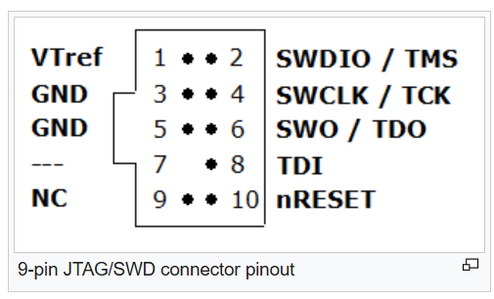
Figure 4-2: 10pin ribbon cable pinout

Pin 1 of J1 is identified on the board by the “J1” silkscreen lettering (Top right of the connector).

SMA Antenna
A redundant antenna circuit with a SMA connected antenna is available on the board for use. Ensure that C31 is not placed if the SMA connector is to be used, and that C30 is not placed if the F-inverted antenna is to be used. When connecting the 50 Ohm antenna ensure that the component is not overtightened. The antenna should be finger tight and snug to the SMA connector. The SMA connector (J15) is located on the board as shown below in Figure 5-1.

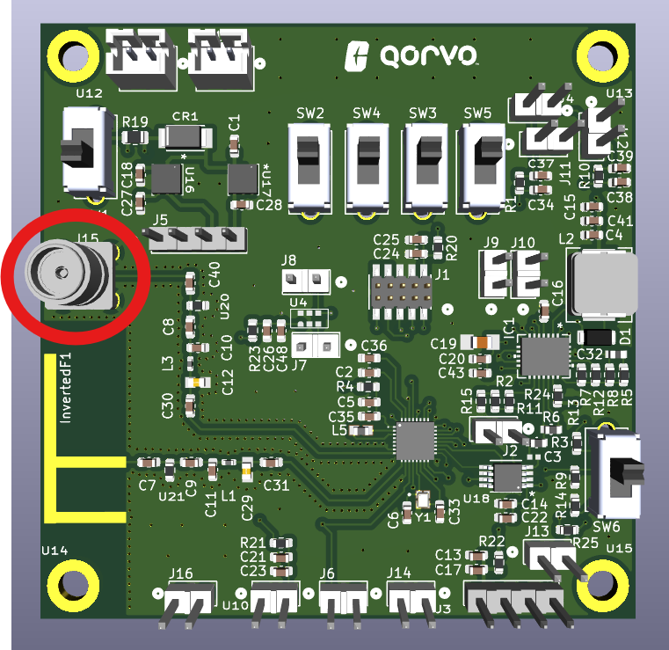
Figure 5-1: 50Ω SMA PCB Connection

Test Headers
Test headers are placed throughout the entire board. The purpose of these headers is to offer a tap in point across critical signal and power lines for trouble shooting. Each test header has 2 pins, one pin for line connection, and the other for GND. Soldering these headers is optional for final product assembly. Each component reference number and pinouts for all test headers are listed below in Table 6-1.

Reference Number | Test Function | Pin 1 | Pin 2 | Pin 3 | Pin 4
J2 | DAC Output | Signal | GND | N/A | N/A
J5 | Power Circuit | V_Source 1 | V_Source 2 | 5V | 3.3V
J6 | Doorbell | Signal | GND | N/A | N/A
J7 | MIC Data | Signal | GND | N/A | N/A
J8 | MIC Clock | Signal | GND | N/A | N/A
J9 | Audio Amp Output - (Before Filter) | Signal | GND | N/A | N/A
J10 | Audio Amp Output + (Before Filter) | Signal | GND | N/A | N/A
J11 | Audio Amp output - (After Filter) | Signal | GND | N/A | N/A
J12 | Audio Amp Output + (After Filter) | Signal | GND | N/A | N/A
J13 | Motion Sensor RX | Signal | GND | N/A | N/A
J14 | Motion Sensor TX | Signal | GND | N/A | N/A
Table 6-1: Test Header Reference table

Doorbell Connector
The RP3502ARED Single Pole Single Throw (SPST) push button switch is utilized as the “doorbell”. This device is connected utilizing a 2 pin connector (U10) located at the bottom of the PCB as shown below in Figure 7-1.

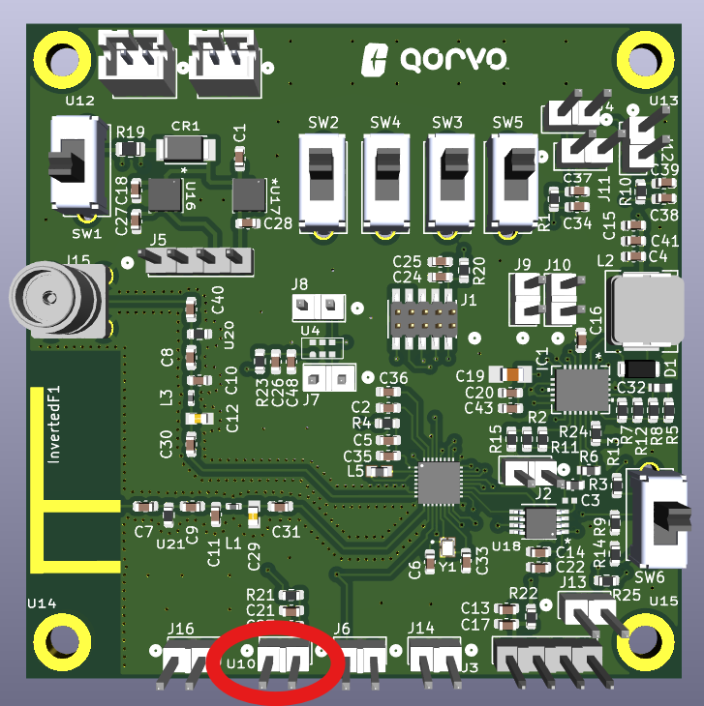
Figure 7-1: Doorbell PCB Connection

The doorbell is not pin specific, connection orientation does not matter for this device.

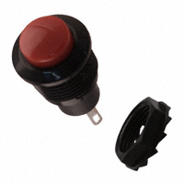
Figure 7-2: Push Button Switch

Motion Sensor Connector
The MB1000-000 ultrasonic sensor is utilized as the motion sensor device. This device is connected utilizing a 4-pin connector (J3) located at the bottom of the PCB as shown in Figure 8-1.

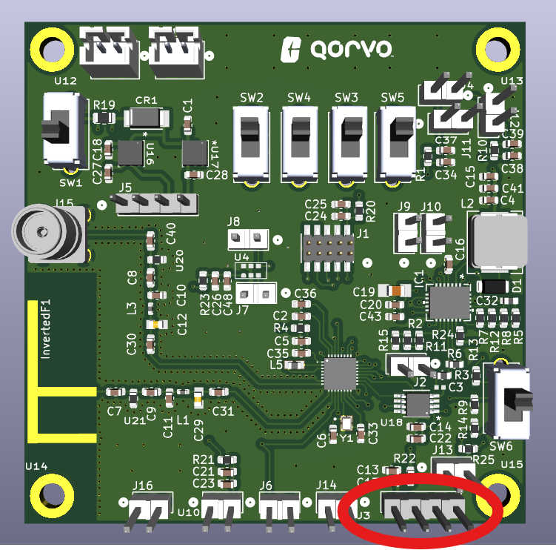
Figure 8-1: Motion Sensor PCB Connection

The 4-Pin connection to the board is orientation specific. Referencing Figure 8-1, pin 1 starts on the left of J3. All pinout connections for J3 are displayed in FIgure 8-2.

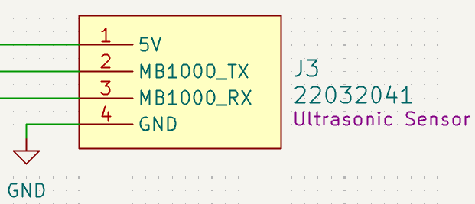
Figure 8-2: J3 Pinouts

When soldering the 4-pin leads to the Motion sensor Figure 8-3 must be referenced to ensure proper connection to J3.

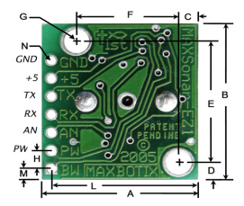
Figure 8-3: Motion Sensor Pinouts

Speaker Connector
The CSS-66668N 8Ω general purpose speaker is utilized as the device's audio speaker. The speaker will be connected utilizing a 2-pin connector (J4) located at the top of the OCB as shown in Figure 9-1.

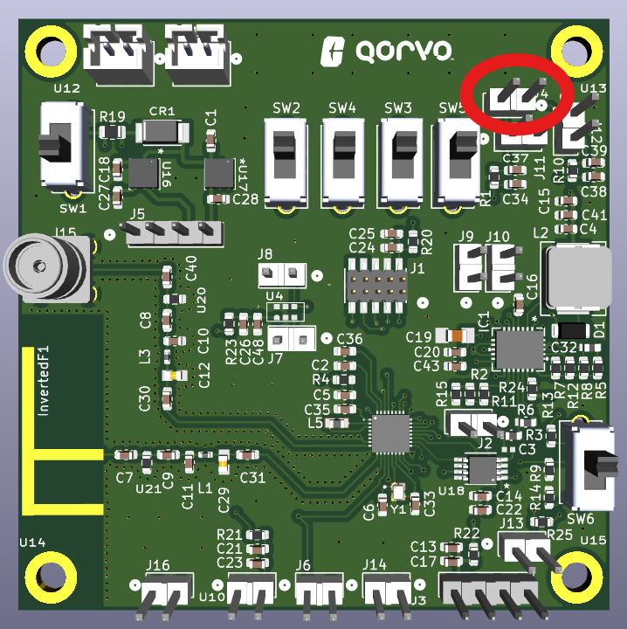
Figure 9-1: Speaker PCB Connection

The orientation of the speaker connection is critical for functionality. Referencing FIgure 9-1, the right pin (Pin 2) must be connected to the negative terminal of the speaker, and the left pin (Pin 1) must be connected to the positive terminal of the speaker. The positive and negative terminal connections will be marked on the speaker with a “+” and “-” respectively.

Spare GPIO
Two spare GPIO’s for the QPG6200L are available for use, these GPIO can be accessed through a 2-Pin Header (J16) located on the bottom of the PCB as shown in Figure 10-1.

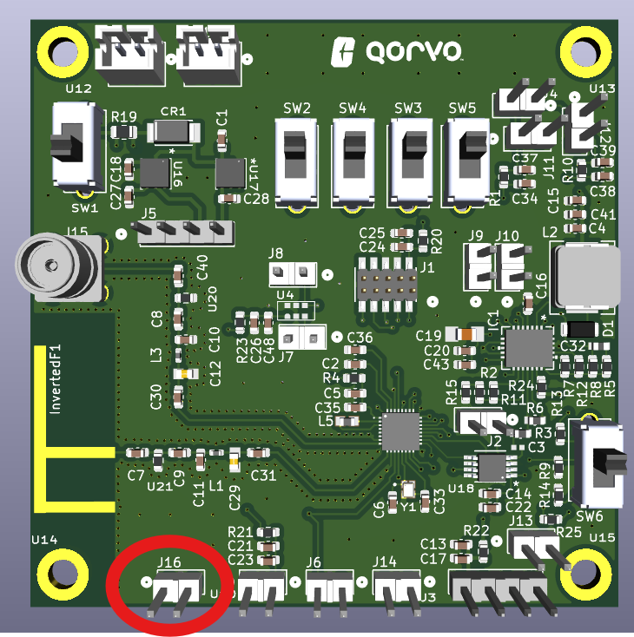
Figure 10-1: Spare GPIO PCB Connection

Referencing Figure 10-1, Pin 1 of the 2-pin header is on the right and Pin 2 is on the left. Pin 1 connects to the QPG6200L’s Pin 17 (GPIO 1), Pin 2 connects to the QPG6200L’s Pin 12 (GPIO 29). Please reference the QPG6200L’s datasheet for each GPIO’s functionality.

Appendix

[A]
TITLE: QORVO_RADIO2_REV2.kicad_pcb
AUTHOR: Luke Matthews
FILE LOCATION: QORVO_RADIO2/Electrical/Hardware/KiCad/REV2
[B]
TITLE: QORVO_RADIO2_REV2.kicad_pro
AUTHOR: Luke Matthews
FILE LOCATION: QORVO_RADIO2/Electrical/Hardware/KiCad/REV2
[C]
TITLE: QORVO_RADIO2_REV2.kicad_sch
AUTHOR: Luke Matthews
FILE LOCATION: QORVO_RADIO2/Electrical/Hardware/KiCad/REV2
[D]
TITLE: QPG6200L Data Sheet.pdf
AUTHOR: Luke Matthews
FILE LOCATION: SD1_QORVO_RADIO2_F25/Research/Electrical

